Overall Suggestions:
- The IEEE papers should not exceeds 8 pages. Reduce 1 page contents from our paper. (suggestions given below )
- Literature Review part should increase with few more references.
- Avoid too many Main Topics and sub topics on all sections. Try to merge the topics with other important main topics. (Mandatory main topics: Intro, Related Works, Methodology, Results and Discussions, conclusion).
- Check the IEEE template for the line spaces between the paragraphs, Font Styles and other formatting aspects.


In Introduction and related works sections, avoid using the subtopics.
Minimum 15 references should be included for our paper.

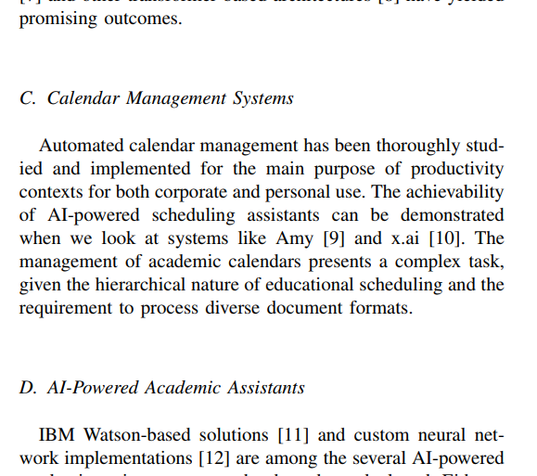
Check the IEEE template for the line spaces between the paragraphs.

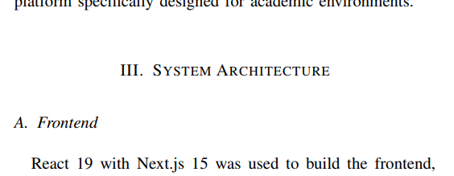
Check the IEEE template for the line spaces between the paragraphs.
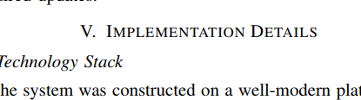
No need to give it as separate main title for this. Either you could merge in other main sections.

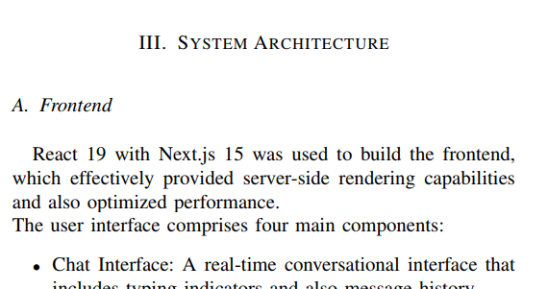
Merge these two sections and reduce the contents.
Bring the System Architecture into Proposed Methodology.
(System Architecture will be the first sub topic in Proposed Method)
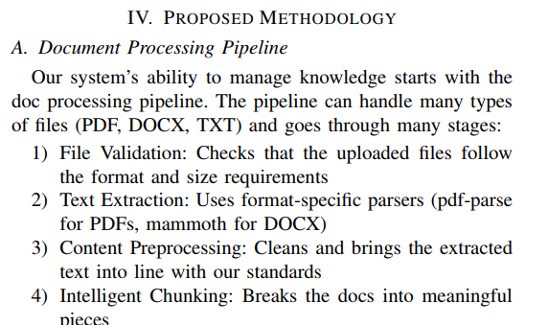

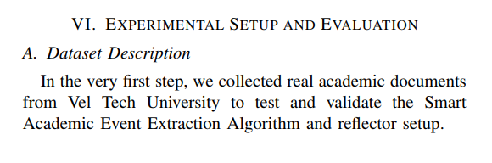
Merge these two sections and reduce the contents.
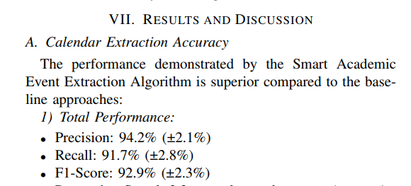
Specify full name of our University
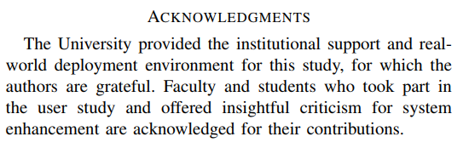
Specify only Conclusion.
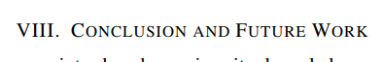
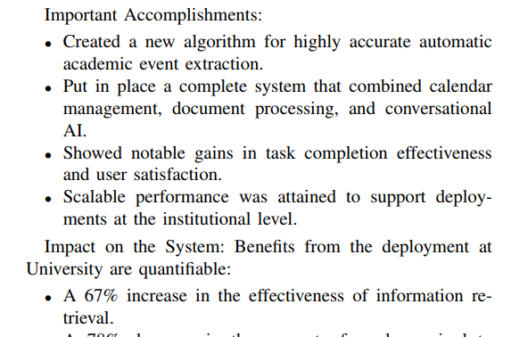
Important Accomplishments: should be brings under the results and discussions part. No need to specify as a separate topic, you could mentions as an outcome of each results or experiments. Then and there you discussed it.

